Vision Statement
The Department of Poultry Science strives to serve the agriculture, food, and health industries by improving poultry management, health, and welfare, the quality and safety of poultry products, and human health through excellence in education, discovery, scholarship, as well as extension-related service (translational), outreach and engagement to serve stakeholders and the world.

Department of Poultry Science Focus Areas 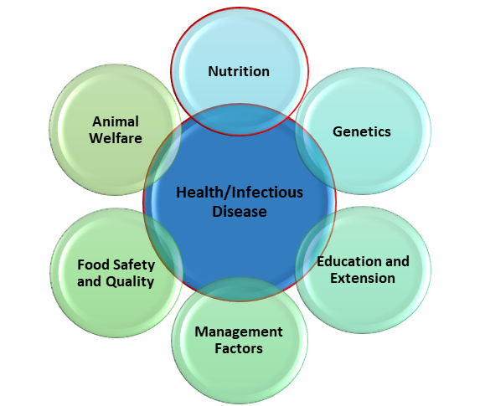

Mission Statement:

Through the advancement of the discipline of poultry science, the department will:

Serve as a global leader in undergraduate, graduate, and post-graduate training that prepares graduates for leadership roles in academia, industry, government, and other sectors with the goal of improving evidence-based decision making around poultry science at all levels from research to application and policy.

Discover new knowledge, technologies, and intervention strategies spanning basic to applied research that provides the foundation for poultry science that can be applied regionally, nationally, and internationally with the goal of improving poultry health, performance, and well-being through genetics, nutrition, and management.

Engage stakeholders and society in the adoption of research applications and knowledge to address challenges and opportunities for improvement of poultry health, performance, welfare, and food safety and quality.

Participate in national and international policy initiatives aimed at improving poultry performance, health, and welfare to bring recognition to Texas A&M while having a positive impact on human health.

Specific Goals of the POSC Department:
To benefit both industry and academic objectives, the department has outlined the following goals which can be met with strategic short and long term investments:

Goals | Approach
Drive the next generation of nutritional interventions for poultry performance and health in non-antibiotic production practices. | Investigate the basic influence of nutrition on poultry performance and health, the interface of nutrition with other physiological systems and disciplines and the impact of nutrition on sustainable poultry production systems.
Lead the development of strategies to combat disease and improve poultry health and performance. | Clarify the mechanisms of poultry diseases, develop vaccines and other pathogen-reduction strategies or technologies, and determine a better understanding of how environmental and avian microbiomes can influence poultry health and welfare, nutrient utilization, performance and commercial production sustainability.
Pioneer the development and adoption of poultry genetic innovations. | Identify the genetic basis for physiological changes, disease resistance, microbiome balance, nutrient utilization, production efficiency and sustainable production systems. Generate new knowledge using conventional breeding and gene editing techniques.
Capitalize on the interdisciplinary potential of chicken as a biomedical model. | Develop and implement avian models for human biological conditions and innovative technology for genetic improvements, production efficiency, disease prevention or disease diagnosis to diversify sources of funds for the department, college and university.
